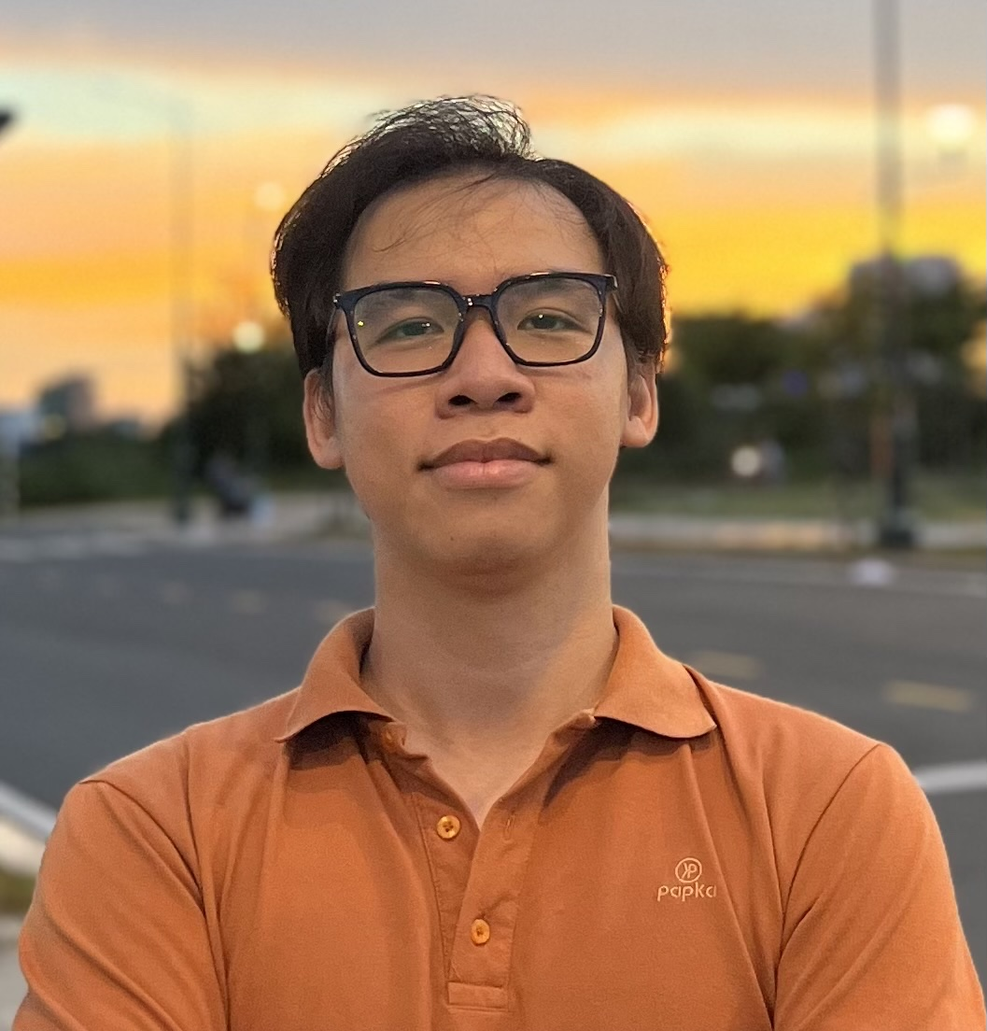

**PERSONAL DETAILS**

* Name **Nguyen Lam Hai Son**
* Nationality Vietnamese
* Gender Male
* Birthday 22/10/2000
* Phone 0345299087
* Email hson22102000[@gmail.com](mailto:hieulam352@gmail.com)
* Address Ho Chi Minh, Vietnam
* Git <https://github.com/HaiSonMin>

**EDUCATIONAL BACKGROUND:**

* Automation Electrical Engineer – Ho Chi Minh City University of Transport – FEUT

**JOB POSITION:** Fresher FullStack Nodejs-ReactJs

**SOFTWARE**

* **Programming Languages:** HTML5, CSS, SCSS , JavaScript, TypeScript, Java, Nodejs,...
* **Database**: MySql, Sql Server, MongoDB,...
* **Programming Tools:** Visual Studio Code, IntelliJ,...
* **Framework/ThirdLibrary:** ReactJS, Redux, Redux-toolkit,React Query, Bootstrap, Tailwind, SpringFramework, SpringBoot, NodeJs,...
* **Tools**: MySQL, SQL Server, GitPash, MongoCompass ,Postman, Docker, Redis...

**WORK EXPERIENCE**

**August 2023 – Now:**

|  |  |  |
| --- | --- | --- |
| Position |  | FullStack Developer |
| Organization |  | Freelance |
| Job description |  | Ecommerce Application Website(Dien May Xanh Clone) |

**Work Description**:

1. Use OTP and captcha authentication for registration, login, forgotten password, and can login by google
2. Create a good user experience when paginate does not require loading
3. Use realtime chat for admins and users to interact
4. Use redis to optimize the number of requests to the server
5. Use elasticsearch to find products by title, description, attribute faster and more accurately
6. Use rabbitmq to be able to send notifications when there are discount vouchers or new product launches.
7. ….

**Technologies/tools using:**

* DesignPattern (SingleTon, Attribute, Pholymorphic,...)
* NodeJs
* ReactJS
* MongoDB
* Postman
* Git/GitHub
* SocketIO
* Redis
* Docker
* RabitMQ
* ElasticSearch
* Kubernetes(I'm studying and will add it later)
* MicroService(I'm studying and will add it later
* AWS(I'm studying and will add it later)

**Link Github:** <https://github.com/HaiSonMin/ProjectEcommerce>

**May 2023 – August 2023:**

|  |  |
| --- | --- |
| Position | Backend NodeJs |
| Organization | Wisdom Engineering and Business Solutions |
| Job description | Delivery App |

**Project Description**: Together with the team, we created a mobile delivery application system, the server side was coded by nodejs

**Work participation:**

1. Determine the number of database elements and create the database.
2. Used design patterns to make it easy to expand on the backend.
3. Create features to add, delete, edit, product information, user accounts, discount codes, order information,...
4. Used design patterns in mongo to optimize search

**Technologies/tools used:**

* DesignPattern
* NodeJs
* MongoDB
* Postman
* SocketIO

**April 2023 – May 2023:**

|  |  |
| --- | --- |
| Position | Backend and Frontend |
| Organization | None |
| Job description | Book library management |

**Project Description**: Project borrows books from the library and can be purchased through card payment.

**Development Steps**:

1. Determine the number of database elements and create the database
2. Create packages to easily code and debug on the back-end(config, dao/repository, service, controller, dto, utils,...)
3. Configure front-end interface, install 3rd library and interface code
4. Test Rest API and deploy on github

**Technologies Used:**

* HTML5, SCSS, Typescript
* ReactJS
* Bootstrap
* Okta
* Oauth2
* Java Spring Boot
* Hibernate , JPA
* MySql
* Postman
* Git

**PROFESSIONAL SUMMARY**

* Can research new technology. Teamwork and good communication.
* Knowledge of relational database
* Knowledge about managing and using git
* Able to withstand high pressure at work, eager to learn, proactive in solving problems.
* Able to read and understand English documents

**Future plan:**

* Learn more Microservices Architecture, Docker, Kubernetes, AWS,… after working time
* Learn more about optimizing databases to be ready to work with large systems
* Fluent in English communication in the next 6-8 months
* Become a full-stack developer in the next 1-2 years
* Become a Devops engineer in the next 4-5 years
* Enjoy life with passion for programming